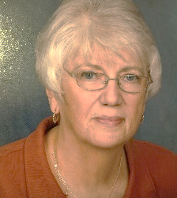 | Alabama  “Joy is in the Little Things”  Kathleen Camardella  bigredhanceville@yahoo.com |  | 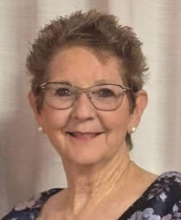 | Arizona  “Our ESA Compass”  Terrie Rust  terrie_rust@hotmail.com
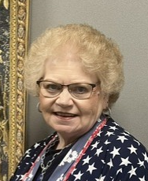 | Arkansas  “Sparkle and Shine with ESA”  Tammy Akines  tsakines@yahoo.com |  | 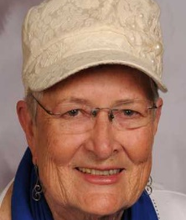 | Colorado  “You've already earned your wings in ESA, now JUST FLY!”  Nancy Cameron  ncnoremac@aol.com
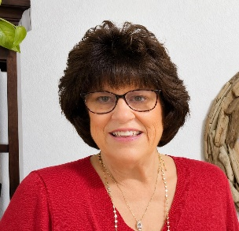 | Florida  “Alone we can do so little, TOGETHER WE CAN DO SO MUCH”  Karlene Beville  bevillek@gmail.com |  | 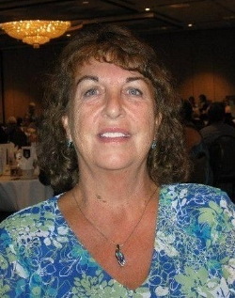 | Georgia  “Encourage - Support - Appreciate”  Sharon Smoot  hanrahan88@yahoo.com
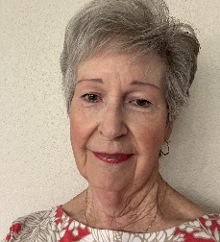 | Idaho  “Friendship Garden”  Karen Bancroft  bkbanc@verizon.net |  | 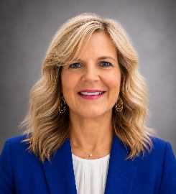 | Illinois  “Take a Walk on the Wild Side with ESA!”  Kelly Purvis  esakellypurvis@gmail.com
 | Indiana  “Transforming the Future Through ESA”  Pam Vogel  esapamv@yahoo.com |  |  | Kansas  “Cruising through life with ESA”  Amanda Johnson  akj828@gmail.com
 | Kentucky  “Celebrate What’s Right”  Erin Baker  eebaker5@gmail.com |  | 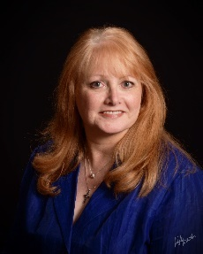 | Louisiana  “Teamwork Makes the Dream Work”  Nancy Darland  ndarland@suddenlink.net
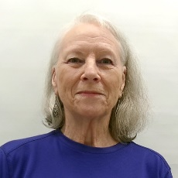   | Michigan  “It’s a Beautiful Day to Save Lives!”  Sara Wachowicz  mamastarshine830@gmail.com  Minnesota- Co President  “Embrace Your Journey in ESA!”  Betty Robinson  bettyarobinson@comcast.net |  | 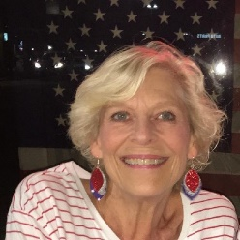  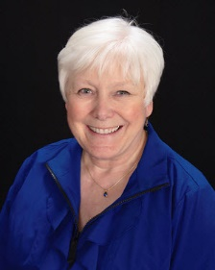 | Minnesota- Co President  “Embrace Your Journey in ESA!”  Terri Olsen  terri.mnesa@gmail.com  Mississippi  “ESA: Kindness in Action”  Casey Hoffman  kchoffman@hotmail.com
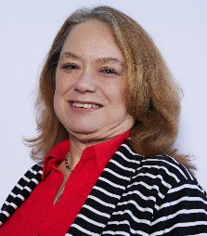 | Missouri  “Build a Bright Future”  Anne Murry  Kyra_anne@yahoo.com |  | 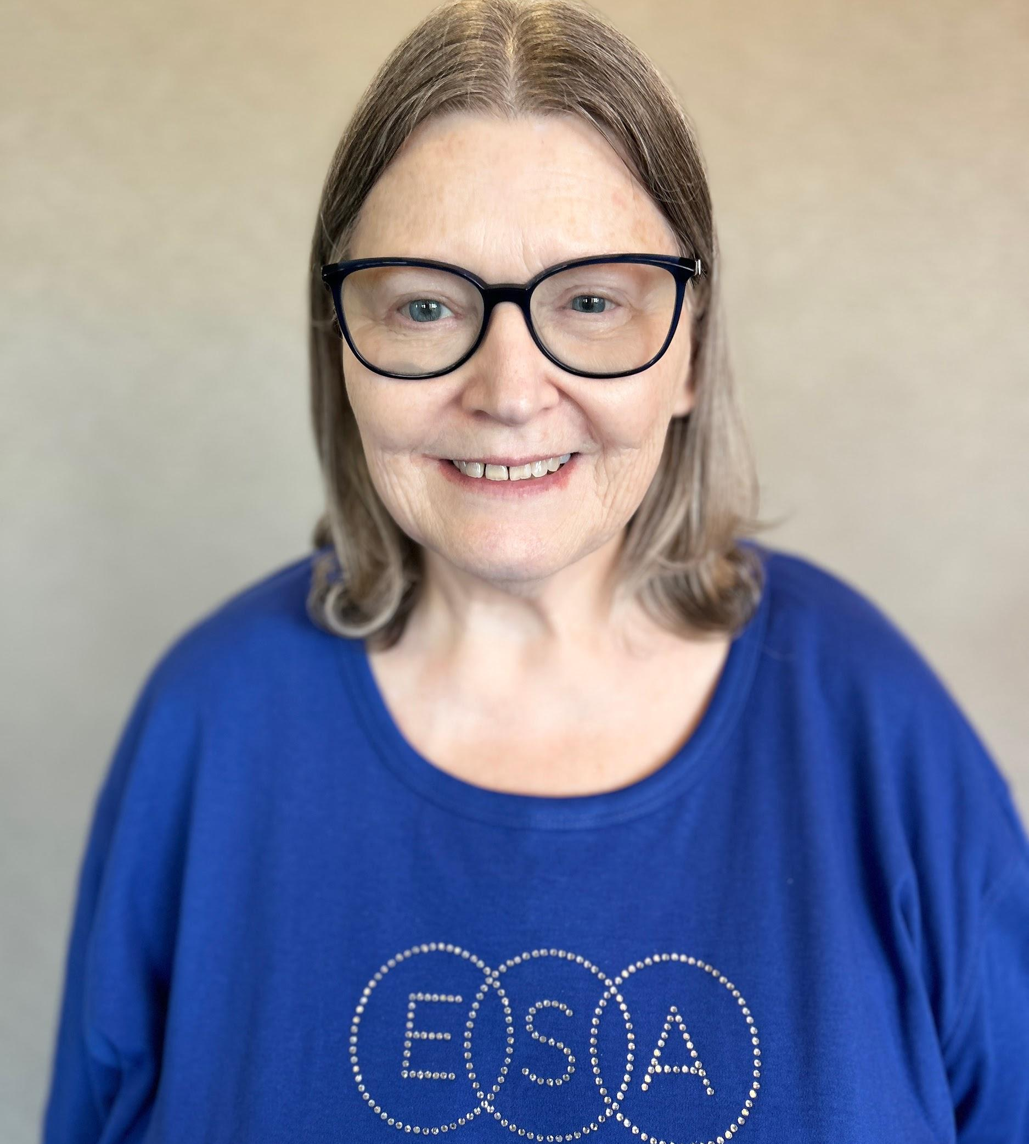 | Nebraska  “Treasure Your ESA Journey”  Deb Vercellono  debrajv@airmail.net
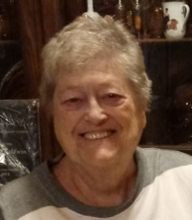 | New Mexico  “Soar Like an Eagle with ESA”  Collene Baldwin  baldwinEC72@hotmail.com |  | 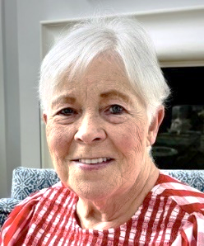 | North Carolina  “Stand Up for ESA”  Mary Smith  mhp.smith@yahoo.com
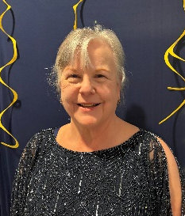 | Ohio  “Dream Big with ESA”  Theresa Snively  tsnively@me.com |  | 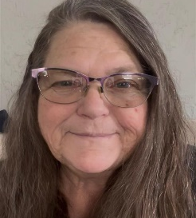 | Oklahoma  “It Takes a Village to Make the Dream Work”  Tammy Ramirez  Momofall4@yahoo.com
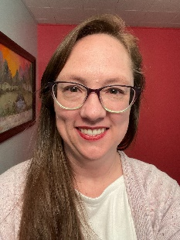 | Oregon  “A Basket of Joy in ESA”  Melanie Wilson  Swann.m@hotmail.com |  | 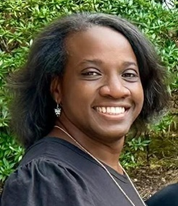 | South Carolina  “Serve and Laugh Together with Great Friends”  Tywanda Atkinson  tywanda026@yahoo.com
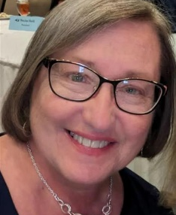 | Tennessee  “Planted in ESA”  Pam Brown  kptsweetie@yahoo.com |  | 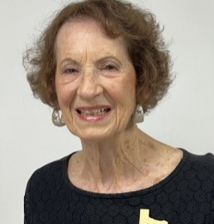 | Texas  “BEE the Best That You Can BEE”  Barbara Price  esabarbara@swbell.net
 | Utah  “Kindness Creates Ripples”  Carol Priest  priestca@comcast.net |  | 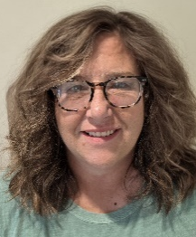 | Virginia  “A Salute to Service, Honoring the Hearts of ESA”  Stephanie Hess  stephanie.s.hess@gmail.com
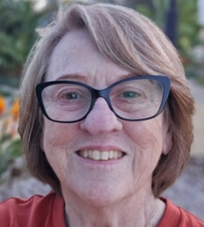 | Washington  “From Northern Lights to Evergreens, Walk a New Path with Me”  Pam Munson  pmunson55@aol.com |  | 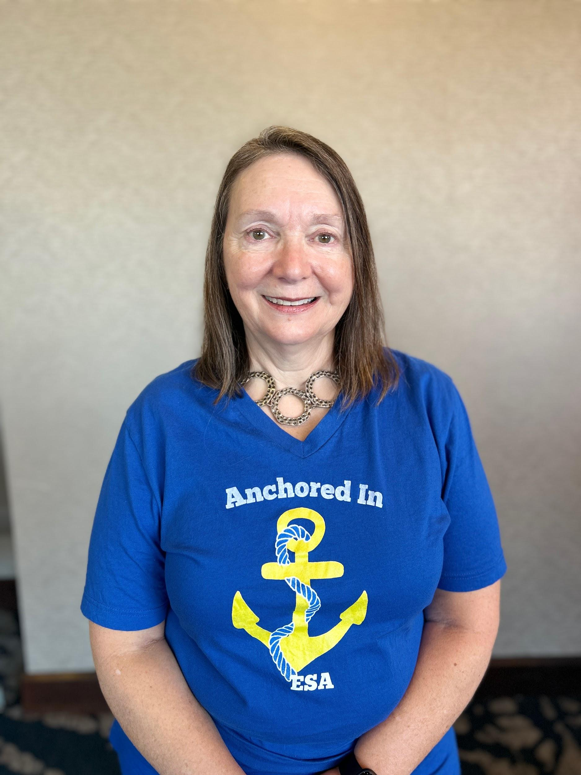 | Wisconsin  “Finding a Way in ESA”  Judy Baxter  Judybaxter6@gmail.com
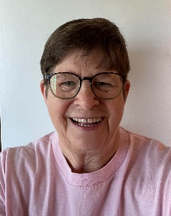 | Wyoming  “Be the Light with ESA”  Pat Endean  pjendean@msn.com |  | 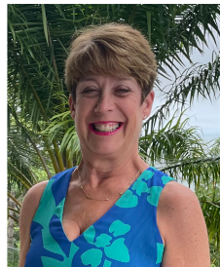 | Midwest Region (MARC)  “MARC the World with Sparkle”  Julie Whitaker (2025-2026)  esajuliew@gmail.com
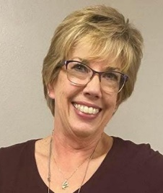 | Midwest Region (MARC)  “Be a MARC Warrior”  Beth Pompa (2026-2027)  Beth.pompa@scbglobal.net |  | 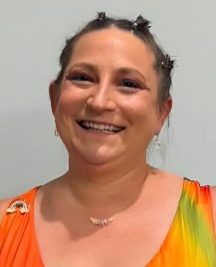 | Southeastern Region  (SERC)  “Beyond the Rainbow”  Lauren Ryan (2025-2026)  laurengeryan@gmail.com
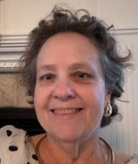 | Southeastern Region  (SERC)  “Birds of a Feather”  Kelli Thornberry (2026-2027)  kjthornberry@yahoo.com |  | 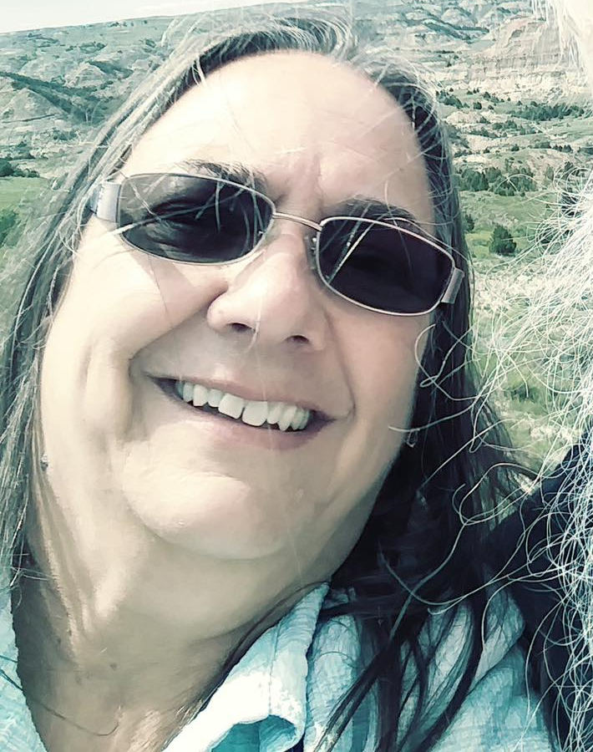 | Rocky Mountain Region (RMRC)  “ESA - The Things That Hold Us Down Can Lift Us Up”  Vickie Chavers-Bruso  kvbruso@aol.com
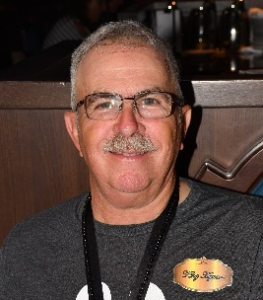 | Western States Region (WSRC)  "Generous Hearts Watching Sunrise & Sunsets in ESA”  John Vitt  vittjc@aol.com |  | 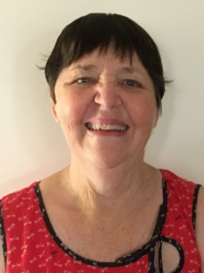 | Australia  "Wherever Life Plants You, Bloom with Grace"  Robyn Creighton  lcreight@bigpond.net.au

