Philanthropic Service Guidelines

The purpose of these Guidelines is to clarify that our philanthropic service is the time and money directed toward the betterment of mankind - to improve the condition and promote the welfare of those who are in need of it. These guidelines are for the purposes of ESA recognition and do not necessarily reflect IRS requirements. Please consult your accountant for clarification.
- General Information
- Hours and monies donated by an ESA member in “the name of ESA”, can be counted.
  - Hours represent the time spent from beginning to completion of a project.
  - Monies represent cash donations from the chapter treasury or by a chapter member to a service project.
- Donated Goods are estimated by figuring 15% of the retail value on used items and full retail value on new items.
- Roundtrip mileage (for driver only) on an ESA service project may be counted. For current rates, use the current IRS rate as of August 1st which is noted on the attached form.
- Civic services are community projects, not necessarily related to ESA projects.
- Individuals can count volunteer service hours done in an education setting or group activity even if their child is involved. Church activities cannot be counted if a member is employed by the church. Activities done for an organization associated with a church can be counted provided the chapter members are doing their philanthropic works in the name of ESA and it is indicated as an official chapter project in chapter minutes.
- Service monies are the portion of ways and means projects donated to charitable and civic projects.
  - If all the proceeds are donated, count all monies and total hours spent raising funds. If proceeds are divided among several projects, monies and hours should be divided on a percentage basis.
  - If only a portion of the proceeds are donated, count only a portion of the hours and money. Figure which percent of the net proceeds is being donated, and count the same percent for hours.
  - If a fundraiser event is specified or advertised as a “benefit” for any philanthropic
project(s) total net proceeds must be donated to project(s).
- Hours and monies for ESA Affiliated Projects (i.e., St. Jude Children’s Research Hospital ESA for St. Jude, National Easterseals Society, ESA Disaster Fund, and ESA Foundation) should be counted the same as any other project.
- Special
  - Babysitting-member may count hours on a project when sitting for an ESA member working on an ESA service project. (Do not count monies paid to a sitter)
  - Aid to an ESA member - count hours/monies should a member be “in need or disabled”
due to chronic/terminal illness or other disaster or extreme setback.
  - Blanket Statement – At the beginning of the year, Chapters should indicate all of their major projects; members can count hours/monies donated towards these specific projects. All philanthropic projects are to be listed in the Chapter’s minutes.
  - Snowbirds – If a member belongs to a different chapter while away from her home chapter for a period of time, she is allowed to report hours and/or monies for ESA philanthropic projects/events in accordance with the chapter that sponsored the project
Philanthropic Year – June 1 - May 31 is the Reporting Period. These dates are for the IC Philanthropic year for reporting and competing in awards presented at the International Convention only. This should not be made a requirement for each State or Chapter to follow for philanthropic reporting.
- Clarifications
  - Homemade Items donated to a philanthropic-service project – count time spent making, baking, etc. and the value of materials used in the items. Homemade items cannot be counted as cash until they have been sold.
  - National Drives, Radiothons/Telethons
    - When an event is totally organized by ESA, count all hours worked
    - monies received, less expenses
    - If a Chapter only performs part of the work, count hours only. The percentage factor on the ESA chapter’s responsibilities, and mutual agreement between the fundraising organization and the ESA chapter(s) prior to the event, will determine the monies credited to ESA.
  - St. Jude Children’s Research Hospital
    - Reporting is counted the same as any other ESA service project. Count all hours/mileage and net monies donated.
    - Do not count extra hours or monies spent or a complimentary room voucher for working in a distant city for a St. Jude event.
  - National Easterseals Society
    - Reporting is counted the same as any other ESA service project.
    - Check with your local Easterseal Coordinator relative to the “Cartridges for Kids Easterseals” project.
  - Bloodmobiles and Blood donations
    - Count chapter hours for sponsoring the drive and registering donors, etc.
    - Count ESA member’s blood donation (whole blood = $50 per pint & platelets = $200 per pint)
  - ESA Foundation Turn-Around Fund
    - Make your chapter check payable to “ESA Foundation”.
    - A form can be found on the Foundation website www.epsilonsigmaalpha.org, or through your ESA Foundation Counselor or the ESA Foundation, 363 West Drake Road, Ft Collins, CO 80526. Telephone: (970) 223-2824.
  - Cash Register Receipts
    - Receipts redeemed for computers and other school equipment may be counted as a donation.
    - Count only12.5% of the total amount of the receipt, not the total amount
  - Manufacturer’s Coupons
    - Count manufacturer’s coupons donated as part of a service project as face value stated on coupon.
    - Count chapter hours for preparing donated manufacturer’s coupons

Revised 01/15

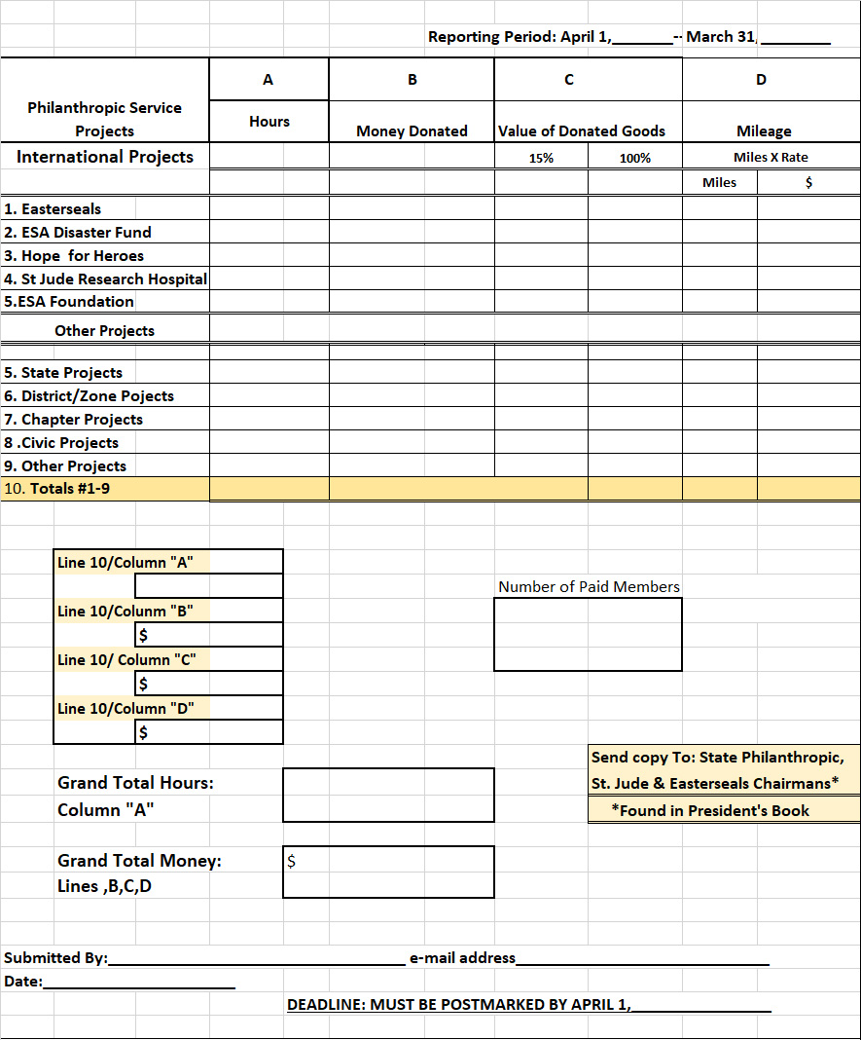
c
Philanthropic Report Form District/Chapter/name/#number _______________

Revised 9/22

