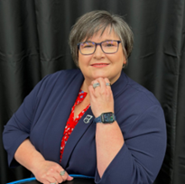
Angie Butenschoen
President
106 Julie Lane
St. Peters, MO 63376
abutenschoen@gmail.com
314-704-1318
Birthday: April 10

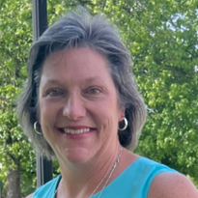
Brenda Campbell
2nd Vice President
4344 N. Co. Rd 400 E
Greenburg, IN 47240
bjic07@gmail.com
812-592-2149
Birthday: April 6

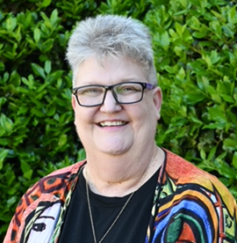
Patti Gale
Treasurer
8901 E. McClellan St.
Tucson, AZ 85710
nacomagale@gmail.com
520-227-4818
Birthday: May 27

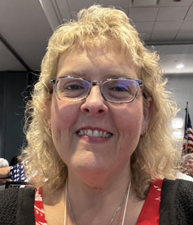
Lynn Howley
Workshop Coordinator
6210 W. 300 N
Boggstown, IN 46110
lehowley92@gmail.com
317-840-0996
Birthday: September 19

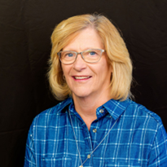
Celeste Webb
Jr. Past President
1120 Richmond Ave
Mattoon, IL 61938
webbfam@consolidated.net
217-276-6568
Birthday: October 12

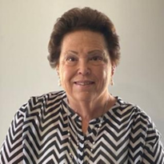
Margaret Kramer
1st Vice President
114625 S. 4172 Circle
Eufaula, OK 74433
mghnurseok@aol.com
918-617-3130
Birthday: June 30

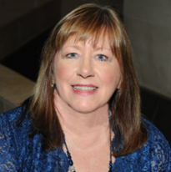
Brenda Fields
Recording Secretary
717 Galveston Court
Moscow Mills, MO 63362
b.fields.esa@gmail.com
636-485-8694
Birthday: July 7

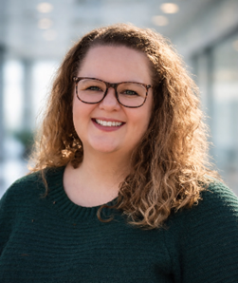
Brittany Covey
26-27 Corr. Secretary
615 Gandalf Ln
Wright City, MO 63390
brittany.covey@bjc.org
314-504-7904
Birthday: September 15

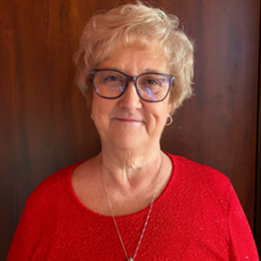
Brenda O’Neill
Parliamentarian
7007 Achieve Dr.
Amarillo, TX 79119
brendaoneill1982@gmail.com
806-382-2925
Birthday: April 1

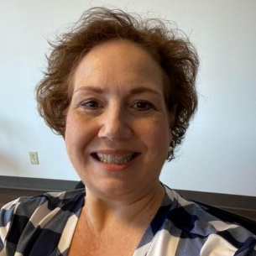
Mara Wheeler
27-28 Corr. Secretary
321 S. Linden St.
Sapulpa, OK 74066
Mara.wheeler@sbcglobal.net
918- 381-6272
Birthday: February 8

