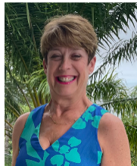 | Administrative Assistant – Julie Whitaker  Email: esajuliew@gmail.com
 | Administrative Assistant – Christy Fritschi  Email: cfritschi2000@yahoo.com
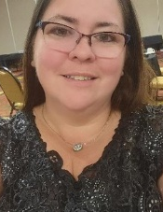 | Administrative Assistant – Carolyn McNamara  Email: Carolyn.mcnamara.esa@gmail.com
 | Administrative Assistant – Ruth Williams  Email: ruthannwms7@gmail.com
 | Association of Arts – Sheri Meyer- Harden  Email: srm2910@gmail.com
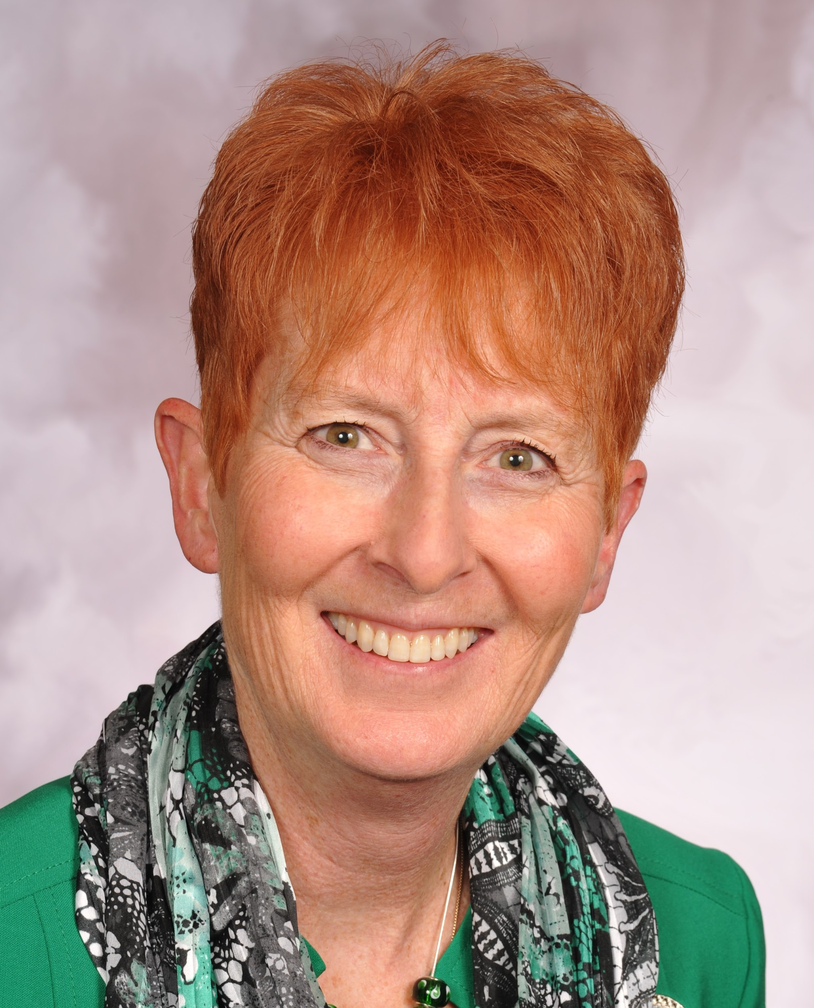 | Audit Chair - Sandy Alexander  Email: sandy.alexander6697@gmail.com
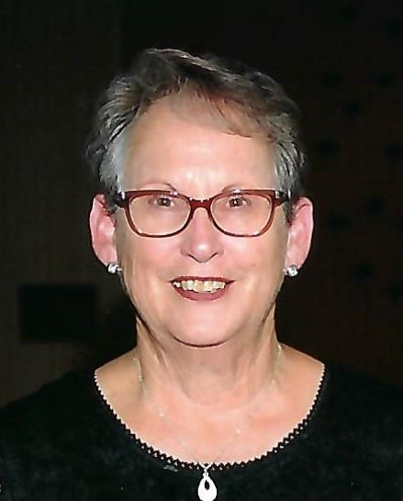 | Audit Committee - Mary Humphrey  Email: esamarykh@gmail.com
 | Audit Committee – Kelli Thornberry  Email: kjthornberry@yahoo.com

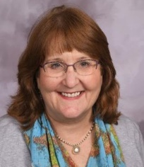 | Audit Committee – Sandra Edwards  Email: sandraedwards1@verizon.net
 | AV Tech – Leanne Dickens  Email: stephanied522@yahoo.com
 | AV Tech - Josh Johnson  Email: josh@josh-sara.com
 | Awards Chairman – Adrian Sperduto  Email: aesperd@yahoo.com
 | Budget Committee Chair – Patti Gale  Email: nacomagale@gmail.com
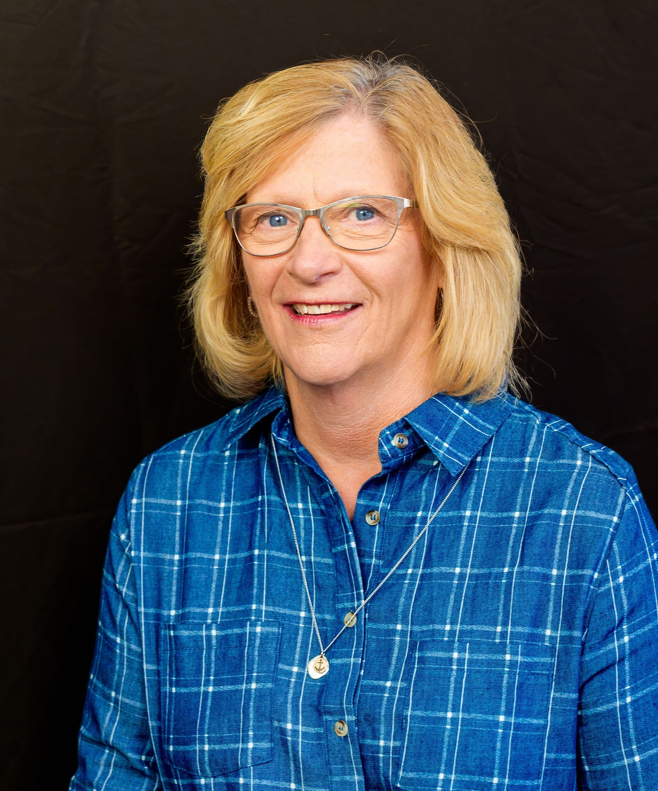 | Budget Committee - Celeste Webb  Email: webbfam@consolidated.net

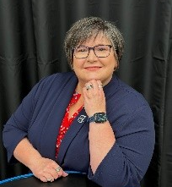 | Budget Committee – Angela Butenschoen  Email: abutenschoen@gmail.com
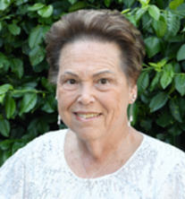 | Budget Committee - Margaret Kramer  Email: mghnurseok@aol.com
 | Budget Committee – Brenda Campbell  Email: brendacampbell040@gmail.com
 | Bylaws Committee Chair – Brenda O’Neill  Email: brendaoneill@suddenlink.net
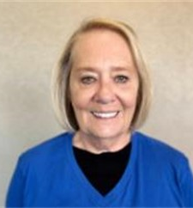 | Bylaws Committee – Joy Lehnert  Email: joy.lehnert@yahoo.com
 | Bylaws Committee- Bonnie Templeton  Email: bonniet56@gmail.com

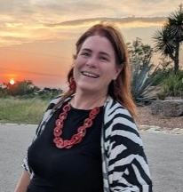 | Interfaith Chaplain – Julie Leith  Email: juliewleith@gmail.com
 | Convention Chair – Connie Russell  Email: cjrseattle@msn.com
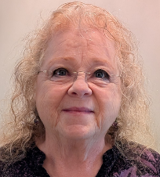 | Convention Co-Chair – Chris York  Email: cristinayork@comcast.net
 | Credentials Committee Chair – Angie Fairbanks  Email: angiekf@gmail.com

 | Disaster Fund Chair – Celeste Webb  Email: webbfam@consolidated.net
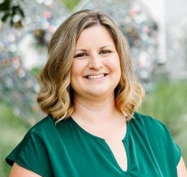 | Easter Seals Chair –Brandy Whittaker  Email: bboone4@elon.edu
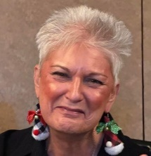 | Educational – Marsha Killam  Email: thekillams74@gmail.com
 | ESA for St. Jude Senior – Kerry Considine  Email: esakconsidine@gmail.com
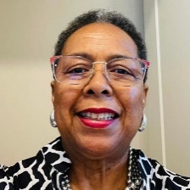 | ESA for St. Jude Junior – Linda Jones  Email: linda.jones93@gmail.com

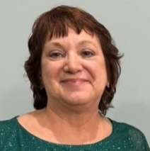 | Hope for Heroes Co-Chair– Dawn Middleton  Email: dawnmiddleton1@gmail.com
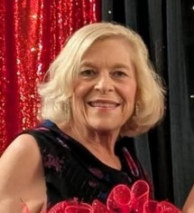 | Hope for Heroes Co-Chair– Casey Hoffman  Email: kchoffman@hotmail.com
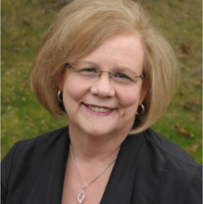 | Hotel Contracts Chair – Sherry Day  Email: sherryday1@cox.net
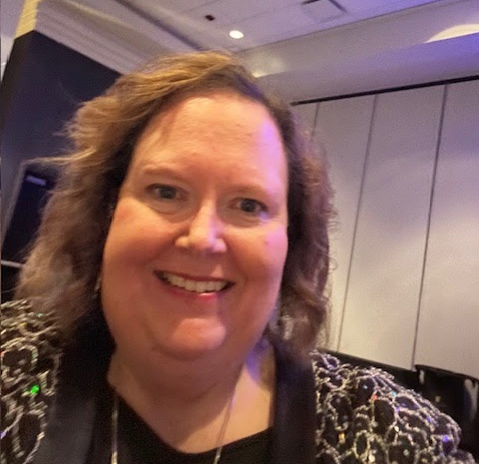 | Hotel Contracts Committee – Jamie Atcheson  Email: Jamiea2@gmail.com
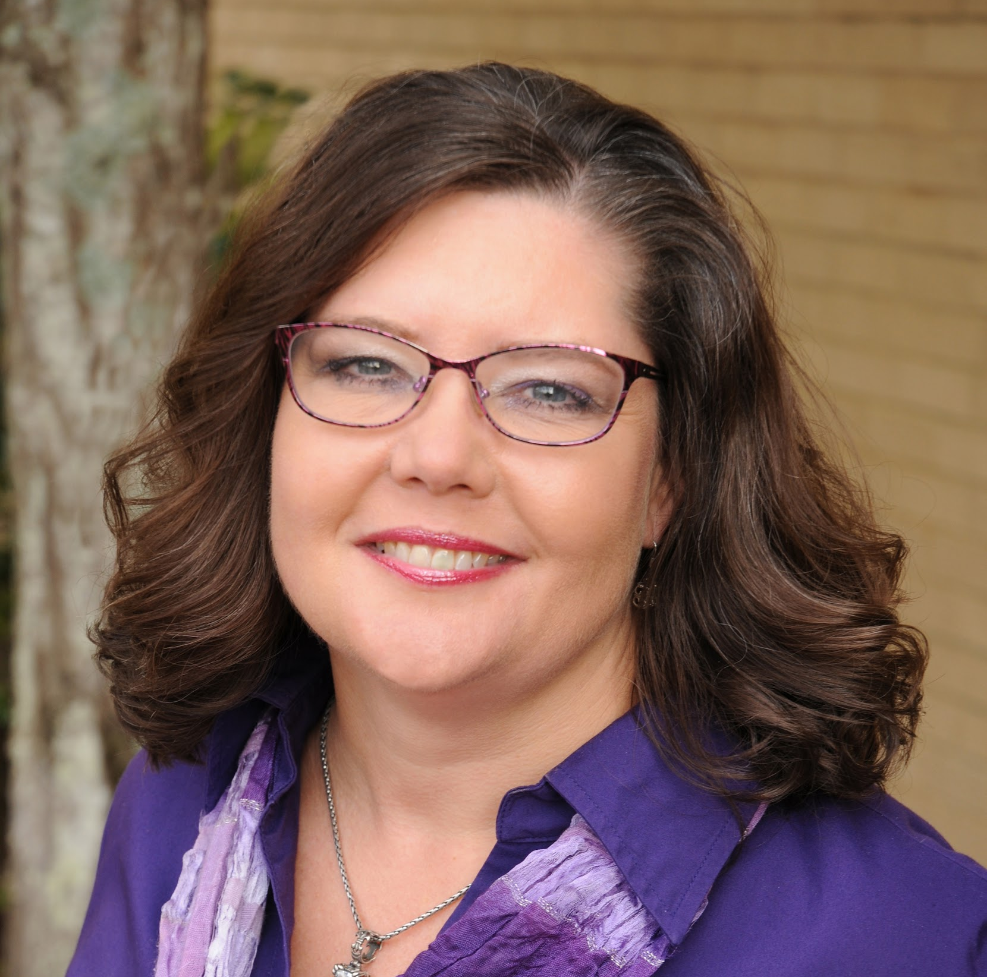 | Hotel Contracts Committee - Kim Kummer  Email: kmkmmr06@gmail.com
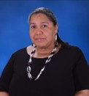 | Membership Chair Senior – Cheri Lee Thomas  Email: cherili@msn.com
 | Membership Chair Junior – Kaycee Headley  Email: kayceeheadley@gmail.com

 | News Bulletin Editor – Alley Gary  Email: alleygary@ymail.com

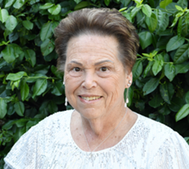 | Nominating Committee Chair -Margaret Kramer  Email: mghnurseok@aol.com
 | Nominating Committee – John Vitt  Email: vittjc@aol.com
 | Nominating Committee – Ruth Williams  Email: ruthannwms7@gmail.com
 | Nominating Committee – Sandy Fletcher  Email: skgood66@yahoo.com
 | Philanthropic Chair – Brittany Rosenmund  Email: britt131222@gmail.com

 | State Presidents Chair Sr. – Jennifer Gailey  Email: thackerchic4@gmail.com
 | State Presidents Chair Jr. – Sara Wachowicz  Email: mamastarshine830@gmail.com
 | Social Media - Reagan Duncan (TikTok/Instagram)  Email: reaganduncan01@gmail.com
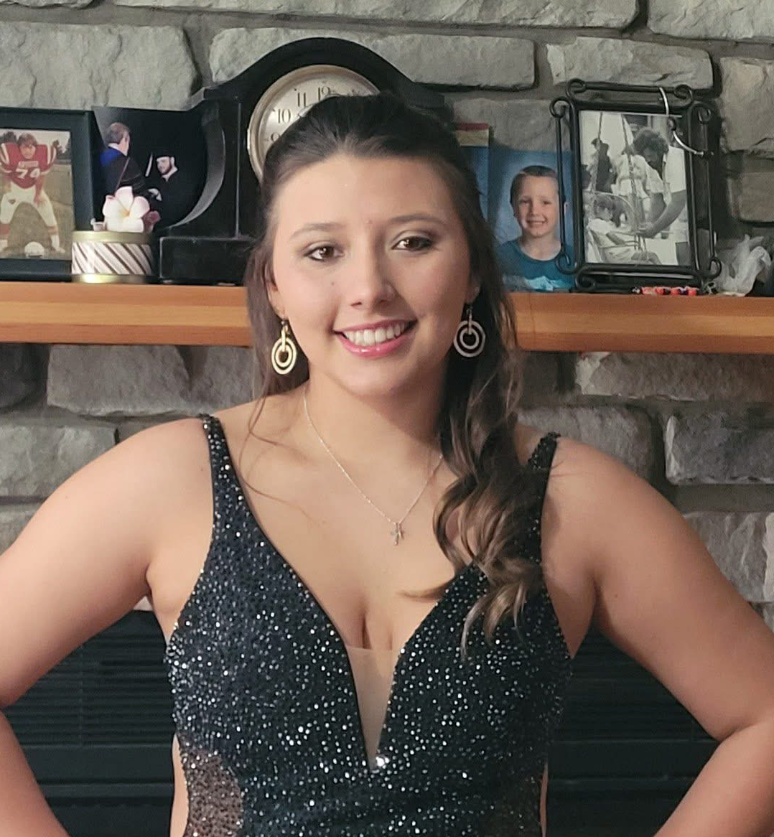 | Social Media - Katheryn Perez (TikTok/Instagram)  Email: perezkatheryn539@gmail.com

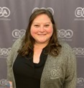 | Webmaster Sr. – Evelyn Greene  Email: evelyn.ann.greene@gmail.com

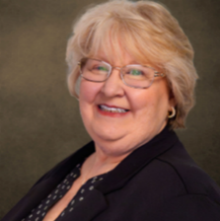 | Webmaster Jr. – Jill Schull  Email: jillshull@icloud.com

